1. Query Using Group By Function

For grouping the items by veg and non veg to see the exact data

SELECT is_veg, count(name) FROM `swiggysqlpractice.fooditems.items`

group by is_veg

1. Query to showcase Count Of Distinct Function

To count the number of different dishes ordered

SELECT count(distinct name) FROM `swiggysqlpractice.fooditems.items`

1. Query Using Distinct Function

To see all the different types of dishes alone ordered

SELECT distinct name FROM `swiggysqlpractice.fooditems.items`

1. Query Using Where Function to Find data based on specific column

To select column based on a specific criteria

SELECT *FROM `swiggysqlpractice.fooditems.items`

where is_veg=2

1. Query showing calculation of distinct numbers

To count number of distinct orders placed

SELECT count (distinct order_id) FROM `swiggysqlpractice.fooditems.items`

1. Query showing Usage of Specific Word Finding Function

When you want line items containing the word chicken

SELECT *FROM `swiggysqlpractice.fooditems.items`

where name like '%Chicken%'

1. Query showing To Count Function and also group function

When you want to know HOW many times EACH ITEM was ordered

SELECT name, count(*) FROM `swiggysqlpractice.fooditems.items`

group by name

Order by count(*) desc

SHEET 2 – Food Item Orders All Queries

1. Query to understand different modes of a criteria using Distinct Function
2. To See the different types of rain_modes

SELECT distinct rain_mode FROM `swiggysqlpractice.fooditems.orders`

1. Query to See Different Names of Places Using Count & Distinct Function
2. To see the number of different unique restaurants we’ve ordered from

SELECT count(distinct restaurant_name) FROM `swiggysqlpractice.fooditems.orders`

To see which was our most favourite restaurant and count that

1. SELECT restaurant_name, count(*) FROM `swiggysqlpractice.fooditems.orders`
2. group by restaurant_name
3. Order by count(*) desc

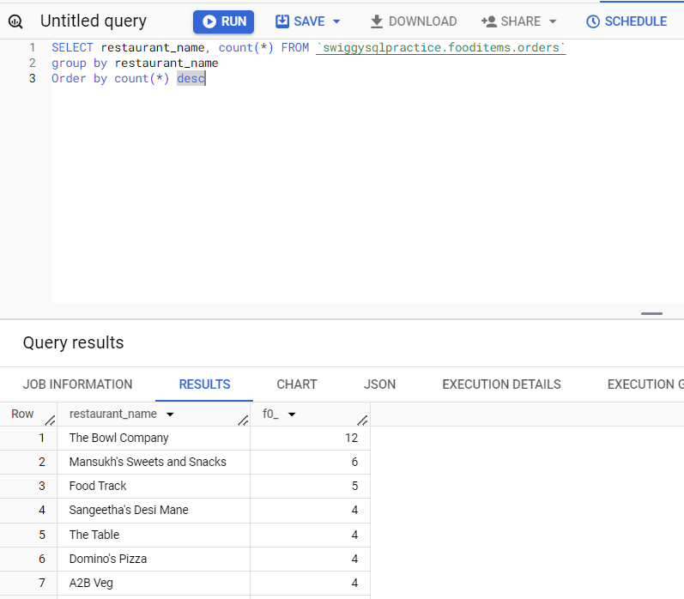

1. Query Using Group, Format Date To Split Summation by Year & Using Order Function

4. To find out how many times order has been made at a restaurant split month wise

SELECT format_date('%Y-%m', order_time), count(order_id) FROM `swiggysqlpractice.fooditems.orders`

group by format_date('%Y-%m', order_time)

order by count(order_id) desc

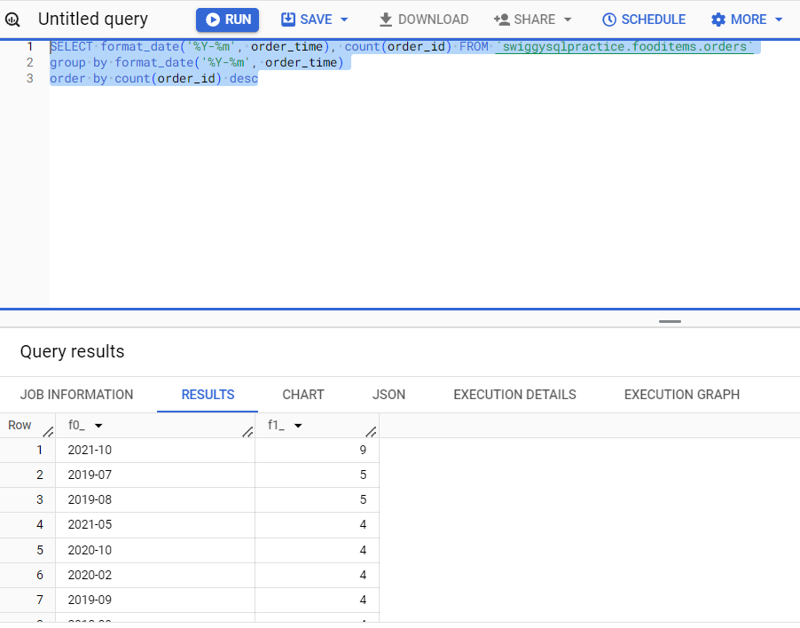

1. Query Using Max Function

5. To find out when the latest order was placed

SELECT max(order_time) FROM `swiggysqlpractice.fooditems.orders`

1. Format Date, Sum, Group by and Order By Query
2. To find out which month we spent the most on food (split month wise)
3. SELECT format_date('%Y-%m', order_time), sum(order_total) FROM `swiggysqlpractice.fooditems.orders`
4. group by format_date('%Y-%m', order_time)
5. order by sum(order_total) desc

1. Query to Calculate a Specific Value

8. To find out the average order value (basically average order value per order)

SELECT sum(order_total)/count(distinct order_id) FROM `swiggysqlpractice.fooditems.orders`

14. Query Using Format Date, Sum & Group by to understand Yearly Expenditure

9. To find out total revenue spent on swiggy per year

SELECT format_date('%Y', order_time), sum(order_total) FROM `swiggysqlpractice.fooditems.orders`

group by format_date('%Y', order_time)

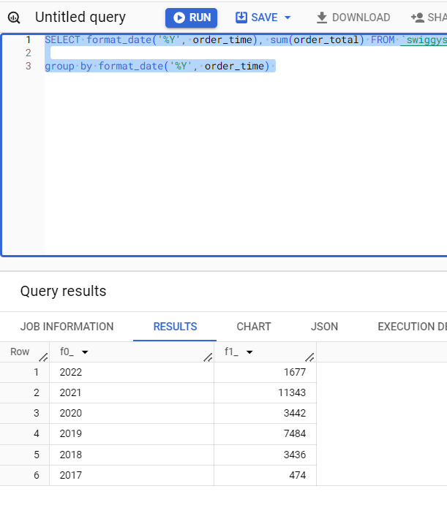

1. Use final window function Query

with final as (

SELECT format_date('%Y', order_time) as `Year`, sum(order_total) as `Revenue` FROM `swiggysqlpractice.fooditems.orders`

group by format_date('%Y', order_time))

select Year, Revenue, lag(Revenue) over (order by Year) as `PreviousYear`

from final

**Output below**

1. To find out rankings of the cost spent yearwise Using Rank Query
2. with final as (
3. SELECT format_date('%Y', order_time) as `Year`, sum(order_total) as `Revenue` FROM `swiggysqlpractice.fooditems.orders`
4. group by format_date('%Y', order_time))
5. select Year, Revenue,
6. rank() over (order by Revenue) as `Ranking`
7. from final

17. Group by Function Query

How much money was during each of the rain_modes in swiggy

SELECT rain_mode, sum(order_total) FROM `swiggysqlpractice.fooditems.orders`

group by rain_mode

18. Query using Inner Join Function

Joining table items and table orders

SELECT a.name,b.restaurant_name, b.order_id, b.order_time FROM `swiggysqlpractice.fooditems.items` as a

join `swiggysqlpractice.fooditems.orders` as b

on a.order_id=b.order_id